

# External Documentation for Project B

Contents

External Documentation for Assignment 4 1

Description 1

Version History 2

Detailed Game Description 3

Controls 3

Characters/Vehicles 3

Enemies 3

Scoring 3

Interface Sketch 4

Screen Descriptions 5

Art Assets 7

## Description

The game is a tribute to space invaders with its own twist.

## Version History

I pulled the version history from github using the shell command:

git log --pretty=format:"%h - %an, %ad : %s"

You can also find it at: <https://github.com/graydon-armstrong/Assignment4/commits/master>

If you want better readability.

4a2c899 - Graydon Armstrong, Thu Jul 11 22:17:54 2013 -0400 : Started External Doc

96404c2 - Graydon Armstrong, Thu Jul 11 22:14:49 2013 -0400 : Added internal documentation

6a03acb - Graydon Armstrong, Thu Jul 11 21:38:19 2013 -0400 : Changed the text for the start and end screens

17b61c5 - Graydon Armstrong, Thu Jul 11 21:19:47 2013 -0400 : Added new image for reward

6426eff - Graydon Armstrong, Thu Jul 11 20:56:40 2013 -0400 : Changed the road background

b52f6a3 - Graydon Armstrong, Thu Jul 11 20:48:52 2013 -0400 : Added Images for the player and enemy

26993cd - Graydon Armstrong, Thu Jul 11 19:59:16 2013 -0400 : Forgot to change date

4f5d147 - Graydon Armstrong, Thu Jul 11 19:57:30 2013 -0400 : Changed to version 2

bcae4ce - Graydon Armstrong, Thu Jul 11 19:55:14 2013 -0400 : Added Loop between game screens

8c8f6c8 - Graydon Armstrong, Thu Jul 11 15:29:31 2013 -0400 : Score between rooms

255b3c7 - Graydon Armstrong, Thu Jul 11 14:41:33 2013 -0400 : Quick edit

79529d4 - Graydon Armstrong, Thu Jul 11 14:32:42 2013 -0400 : Restricted the car to the road

e1fd0b0 - Graydon Armstrong, Thu Jul 11 14:27:36 2013 -0400 : Added Score and Lives to the game

a03e026 - Graydon Armstrong, Thu Jul 11 14:25:27 2013 -0400 : Corrected Images

282e966 - Graydon Armstrong, Thu Jul 11 14:18:49 2013 -0400 : Added Scoreboard

61d7136 - Graydon Armstrong, Thu Jul 11 14:12:53 2013 -0400 : Added Road Background

df3b60f - Graydon Armstrong, Thu Jul 11 13:58:37 2013 -0400 : Added Rewards the player can collect

655fc87 - Graydon Armstrong, Thu Jul 11 12:24:01 2013 -0400 : Make background blank on score screen

42d05ea - Graydon Armstrong, Thu Jul 11 01:14:13 2013 -0400 : Added Temporary Score Screen

c66ea32 - Graydon Armstrong, Thu Jul 11 01:12:11 2013 -0400 : Added Temporary Start Screen

5957526 - Graydon Armstrong, Wed Jul 10 23:16:15 2013 -0400 : Added smooth movement for the player

5ef584a - Graydon Armstrong, Wed Jul 10 22:05:42 2013 -0400 : Changed Drawing

d187948 - Graydon Armstrong, Wed Jul 10 21:31:02 2013 -0400 : Added collisions between the player and enemies

57fb223 - Graydon Armstrong, Wed Jul 10 21:22:56 2013 -0400 : Added a basic enemy that comes on the screen and resets

020ddaa - Graydon Armstrong, Wed Jul 10 20:50:12 2013 -0400 : Created basic game loop with a temporary player object

fe0cec2 - Graydon Armstrong, Wed Jul 10 18:27:06 2013 -0400 : Initial Commit

## Detailed Game Description

The game is a side-scroller where you control a car that has to avoid obstacles and collect rewards. The obstacles are enemy cars that are on the road and if you hit one you lose one of your five lives. The rewards are money on the road that if you collect one will give you 50 score. You play until you run out of lives and then are presented with a game end screen that will display your score and ask you if you want to play again.

### Controls

The user controls the game entirely with the mouse. The user moves the mouse and the car will move at a speed of 5 towards it until it is in line with it. The user also clicks to get through menus and can exit the game by pressing escape of the x in the upper right hand corner of the window.

### Characters/Vehicles

The player is a blue car.

### Enemies

The enemies are rotting junk cars.

### Scoring

The user scores 50 points whenever he collects the money on the road.

## Interface Sketch

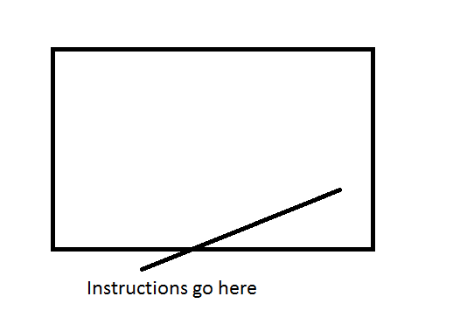

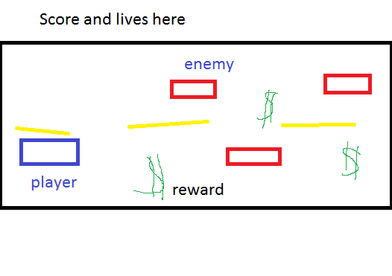

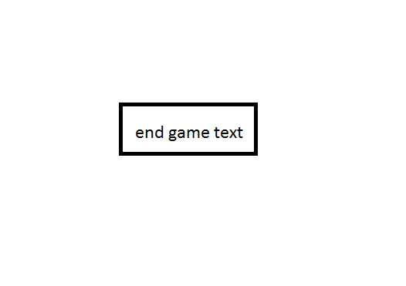

## Screen Descriptions

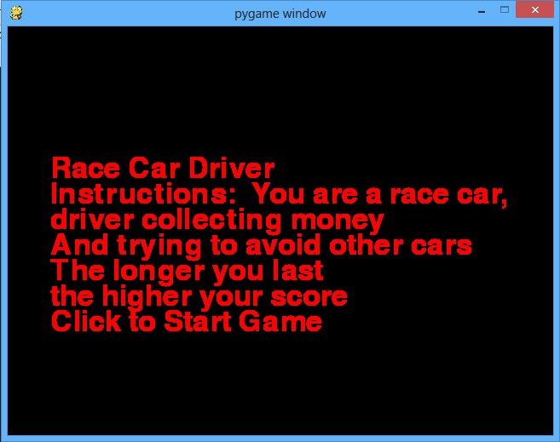

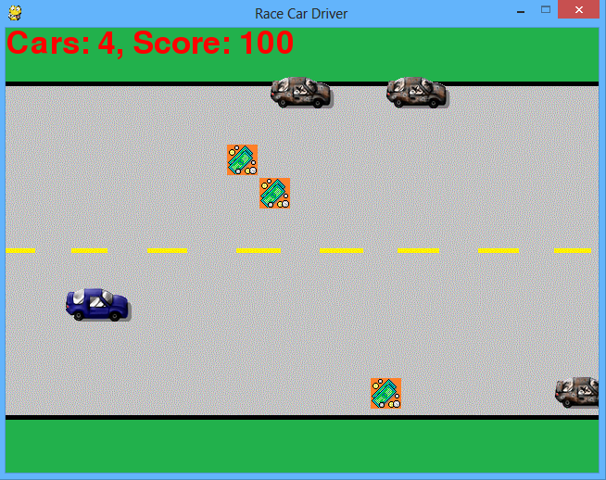

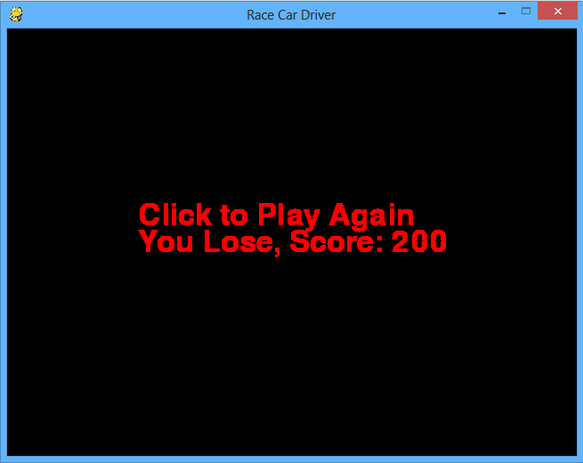

## Art Assets

 Player

 Reward

 Enemy

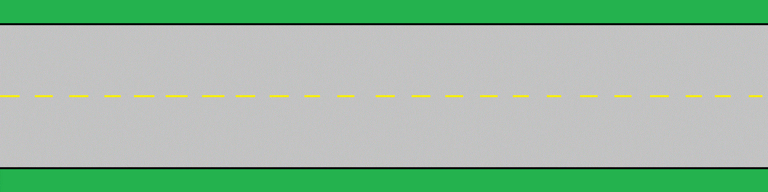

Background